PSYCH SKILL TRAINING
Definition: PST refers to the systematic and consistent practice of mental or psychological skills for the purpose of enhancing performance. Also enhances athlete enjoyment, and teaches them skills to use in everyday life.
Mental toughness in athletes
- Control: over feelings and actions in all situations (especially stressful ones)
- Commitment: to having an active role in training. Accountable for actions
- Challenge: change seen as an opportunity to grow and develop; not a threat
- Confidence: in their own ability to do well under stressful situations/everyday training.
Why is it important
- Psych factors account for most fluctuations in sport performance from day to day
- Achieving mental toughness=consistent performance
- Increase enjoyment in training and competition for the athlete
Myths about PST
- For elite athletes only
- For problematic athletes only
- Not useful
- Time consuming
- The notion that you’re “just born with mental toughness” and it can’t be learned
Myths busted
- For elite athletes only: the earlier you start the better. Starting to learn psycholigcal skills at an early age means you’ll learn control over emotions/actions in lots of different situations.
- For problematic athletes only: learning skills before you need them, will help the learning process. We learn better when we’re not stressed. If you’re already stressed, makes it hard to retain info (learn in pre season, practise throughout)
- Not useful: False. Can help anyone at any stage including people who don’t compete as these skills are coping mechanisms for everyday situations as well
- Time consuming: mindfulness can be done anywhere at any time for only a few seconds. Once you learn the skills, they’re with you for life so you can use them at any time.
- “just born with it”: not true. You can learn to manage your anxiety during stressful situations. You can deal with stress in a healthy way. Athletes are not doomed for failure if they don’t naturally know how to deal with stress and change. They can be taught.

Ultimately, Mental toughness can be built so that the athlete can deal with stress better.

Skater that falls apart at comps but in training they’re amazing
Stress and Anxiety
What is Anxiety?
“a future-oriented mood state associated with preparation for possible, upcoming negative events”
- Almost universal human experience
- An evolution of primal survival instincts. Fight or flight response: A response which triggers a flood of changes to your hormones, neurotransmitters, and body to prepare you to immediately run away or fight danger
- Aversive experience, stops you from acting in ways likely to compromise your survival
  - Picking a fight with someone much bigger
  - Driving your car at 200KPH
FEAR VS ANXIETY
FEAR: “an alarm response to present or imminent danger (real or perceived)”
ANXIETY “a future-oriented mood state associated with preparation for possible, upcoming negative events”
Functional anxiety
- Anxiety is the normal and adaptive response to anticipated danger
- Prioritises attention on threat appraisal and escape and mobilises bodily resources to deal with the danger (Fight, flight, freeze)
- Fight or flight helpful in certain circumstances
  - Being attacked, car accident or natural disaster
- Unhelpful when inappropriately triggered
  - When giving a speech in class
  - Going on a date or job interview
FEATURES OF ANXIETY
Mental processes:
- Worry, self doubt, FEAR
- Unease
- Repetitive negative thoughts
- Difficulty concentrating
- Confusion
- Depersonalization
Physical features of anxiety... – things to look for in our athletes
- Increased heart rate
- Rapid breathing/Hyperventilation
- Sweating
- Stomach ache
- Headache
- Muscle tension/aches
- Shaking
- Nausea/butterflies
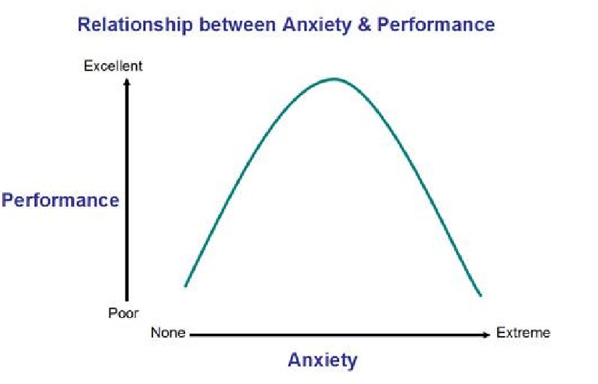
- Not enough anxiety, performance goes done. Extreme anxiety and performance goes down as well. Therefore we need optimal amount of performance.
- BUT, everyone’s curves might be slightly skewed. So someone might perform their best super relaxed with no anxiety or others may perform better with more anxiety.
Fight or flight response
Sympathetic nervous system response: what your body goes through in response to danger
- Cortisol and adrenaline released: get ready to run away from danger. Experienced as jitters and needing to take action
- Heart rate and breathing accelerate: experienced as light headedness
- Pupils dilate: to take on more information to run away from “danger”
- GI processes inhibited: gives energy to muscles rather than digestion as not important in a life or danger situation. Experienced as queasiness/nausea
- Blood flow increases to muscles: to get ready to “fight or flight”
- Glucose released into blood: quick energy to run from danger
- Saliva decreases, sweat increases: saliva is part of digestive system so not needed. Experienced as dry mouth and sweaty palms
Competition as a “danger”
- Competitions produce stress because they are a demanding situation and in order to succeed we must meet those demands
BREAK
How to identify where your athlete sits on the curve to get their best performance every time (comp and training)
AROUSAL REGULATION
STEP 1 SELF AWARENESS
- Self assessment of best and worst performance. Can be done verbally.
1.Think back to your best performance.
2.Try to visualize your actual competition as clearly as possible.
3.Take 5 minutes to relive the experience and then complete the checklist below
4. Repeat the process with the worst performance
5. Compare your results . It is best immediately after the situation. As anxiety/arousal can vary across the situation just repeat the checklist process within each variation
- Important so that both athlete and coach know what the athlete needs pre comp/during training
- With self awareness comes self regulation (in a pre comp situation athlete can scan their physical and mental condition and decide which skill to use to get them back to their optimum level)
STEP 2: Arousal regulation
Over activation / Optimal activation (looks different for everyone) / Under activation
| |
Relaxation techniques Arousal-inducing techniques

SKILLS
- Progressive relaxation (Jacobson 1938)
Based on 3 principles:
- It is possible to learn the difference between relaxation and tension
- Works by relaxing the muscles to relax the mind.
- Based on tension/relax cycles of selected muscles
Once technique is learnt, takes less time to get same effect

- Breath control 4sec to inhale, 8 to exhale
Gives you something else to focus, relax the body to relax the mind.
- Relaxation response
Based on meditation but without spiritual or religious significance. The process teaches you to quiet the mind, concentrate, and reduce muscle tension.
In a quiet place and comfortable position, use a word or thought as an anchor to this moment. Focus your attention on this word and repeat it in your head on every exhale. If something comes into your head, gently re focus on your word on the next exhale.

AROUSAL INDUCING TECHNIQUES
- more common in general training although common in comp too
What it looks like:
- Moving slowly/not getting ready
- Mind wandering; becoming easily distracted
- Lack of concern about how well you perform
- Lack of anticipation and enthusiasm
- Heavy feeling in the legs; no bounce
DON’T TRY RANDOM STUFF DURING COMP IF THAT’S NOT WHAT YOU USUALLY DO. (eg energy drinks)
- Use mood words and positive statements (ie: give them a mantra about what they’re going to do and what to focus on. Make sure it’s positively worded and focusing on getting that energy up)
- Act energized so the energy will rub off on them (or get them to imagine a situation where they are energised)
- Energetic music. Have a dance party
- Complete a precompetitive workout to get the adrenaline flowing (DON’T DO THIS IF THEY HAVE NEVER WORKED OUT IN THEIR LIFE)
RACH TO INSERT MINDFULNESS SLIDES
BREAK

IMAGERY
What is it?:
- Using all the senses to re-create an experience in the mind. Mental practice. It is important to involve as many senses as possible

Where and When?:
- Majority of research has focused on imagery during practice rather than competition but athletes appear to use more imagery during competition (pre-competition)
- Coaches should concentrate on teaching during practise so it can be transferred to competition
- Learning during stressful times (eg competition) can be very difficult as your body is in “flight or fight” mode. Important that skills are learnt during practise in a relaxed environment so that all information is retained and not at competition where there are many distractions
Why?:
- Control emotions and activation levels
- Builds self confidence
- Imagery plays both motivational and cognitive roles in modifying behaviour.
- Can be specific or general towards a situation
- Enhances psych skills: CONCENTRATION,MOTIVATION, CONFIDENCE, EMOTIONAL /AROUSAL RESPONSES
- Enhances sport skills: ACQUIRE, PRACTICE, AND CORRECT SPORT SKILLS. COPE WITH PAIN AND INJURY (very useful for injured athletes or for breaking bad habits)
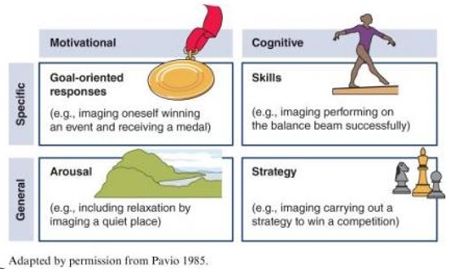

- Competition surroundings (venue, spectators)
Make your athlete imagine the rink they will skate at, where the judges are, where the audience will be, how loud it will be. Imagine themselves coming in, getting ready, warming up, putting skates on. Make sure they imagine this with a clear and calm mind so that they will feel clear and calm on the day. The more you practise this calmness, the more likely it will translate to real life.
- Nature of imagery
Positive imagery is mostly reported during practice and precompetition.
Negative imagery is mostly reported during competition
- during the routine focusing on NOT falling.
- Imagery that creates too much anxiety
- Imagery that directs attention to irrelevant factors
- Imagery that is not controllable (eg other competitors or judge’s thoughts), leading the athlete to imagine failure or mistakes
- Imagery that makes the athlete overconfident

- Type of imagery
Visual and Kinaesthetic most used and are important but the more detail added from other senses, the better. Eg olfactory or auditory. Auditory might be good to imagine a figure situation where there may be noise and so distracting the athlete.
- Imagery perspective
Internal imagery: you see yourself as if you have a camera on your head. Some authors argue that this situation increases performance as it is more specific and accurate to real life situations.
External imagery: you see yourself from a perspective of an outside observer. More commonly used
There is no conclusive research on which perspective is better for the performance.
Quality and detail of the Image is more important
Factors affecting the effectiveness of imagery
- Nature of the tasks: when you’re in a solo sport, good outcome because you have more control over situations
- Skill level of the performer: imagery is useful for learning new skills as a novice. However, experienced performers use imagery more often, mostly for refining skills.
- Imaging ability (quality of image get better with practise
- Using imagery along with physical practice= BEST PRACTISE. Makes learning new skills faster and easier

HOW TO APPLY IMAGERY
- Practice in many settings (before bed, at the rink, during practise, during lunch, pre comp)
- Relax before practicing imagery (deep breaths, comfortable position)
- Avoid negative beliefs (‘this doesn’t work’) about imagery
- Use vivid and controllable images
- Start small. Picture simple things to get the hang of it. Eg just 1 jump rather than a whole routine
- Apply imagery to specific situations or skills
- Use imagery about situations that cause the athlete the most stress. Eg imagine the situations where they’re stressed the most during competition
- Maintain positive focus (imagine performing well)
- Need to spend the same time imagining that you spend performing in a real situation. Eg if routine last 2min then an image of a routine should last 2min.

Coach’s expectation can alter athletes' performance
- Coach forms expectation based on person’s cues (size, gender..) and performance information (skill tests, practice behaviour…)
- Coaches’ expectations influence their behaviour: frequency , quantity and quality of instruction and the type and frequency of feedback is different if you have high expectations than if your expectations are low
- Low-expectation athletes perform poor because their receive less reinforcement and get less playing time. Self-confidence decrease and think that they are not good athletes
- Athletes therefore confirm the coaches expectations.
Not always true. But in order to avoid this cycle we must manage our own expectations as a coach and make sure you treat athletes like you would like to be treated.
Manage your own expectations as a coach
- Communication: making sure it’s athlete centred.
- Always working towards the athlete’s needs and goals, not towards your own.
- You’re more than a coach, you’re a mentor. They look up to you.
- Neutral talk: don’t lead the conversation about bad or good performances with positive or negative talk. Pick words wisely. Try get your athlete to self evaluate their performance. Eg After a bad routine, instead of asking “well that was a bad routine!” or even “you did your best but...” try saying “some days aren’t as expected but what did you think of that routine?” “what was going through your head during or after that routine?”
- We’ve all been there, the skater already knows they’ve had a bad day, help lead the conversation towards a more positive stand point to build up their confidence
- SELF REGULATE FOR YOUR ATHLETE: most difficult skill to grasp. We must learn to take a deep breath and not let our expectations and disappointments show

