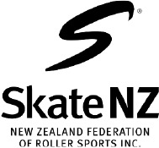
CERTIFICATE OF AUTHENTICTION
OF MUSIC CHOSEN FOR “STYLE DANCE”

I*, ______________________(1), as _________________________(2) certify for the appropriate action that the musical composition skated by _______________________________________________________(3), based in ______________________(4) for Style Dance by World Skate Technical Commission of the current year, is authentic repertoire of __________________________(5), obeying the mandatory requirements for the music of the Pattern Dance Sequence ___________________(6), from ____/____(7), respecting the rhythm _________________(8) and the allowed ____(9) bpm.

SIGNATURE:

DATE (dd/mm/yyyy):

*note: This must be certified by a “professional” person who is qualified to sign the form, and not by a teacher at school, or a private person who plays an instrument
(1) Name of person authorising
(2) Person authorising qualifications
(3) Name/s of Skater and Country
(4) Theme of the Style Dance
(5) Rhythm/s chosen
(6) Name of the Compulsory Dance
(7) Time of when the Step Sequence starts / Time of when the Step Sequence ends
(8) Rhythm of the PdStSq
(9) Tempo form the piece of music of the PdStSq

